DATA SCIENCE & MACHINE LEARNING-LAB CYCLE 2

- Create a three dimensional array specifying float data type and print it.

CODE:
import numpy as np
a3d_array=np.array([[[1.1,2.1],[3.1,4.1]],[[5.1,6.1],[7.1,8.1]]],dtype=float)
print(a3d_array)
OUTPUT:
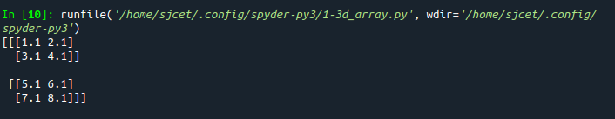
- Create a 2 dimensional array (2X3) with elements belonging to complex data type and print it. Also display
- the no: of rows and columns
- dimension of an array
- reshape the same array to 3X2

CODE:
import numpy as np
x=np.array([[1+2j,1+3j,2+3j],[5+6j,3+8j,4+5j]])
print(x)
print("Number of Rows and Columns:",x.shape)
print("Reshaped matrix is:")
print(x.reshape(3,2))
print("Dimensions:",x.ndim)
OUTPUT:
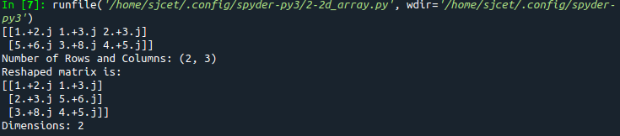
- Familiarize with the functions to create
- an uninitialized array
- array with all elements as 1,
- all elements as 0

CODE:
import numpy as np
x=np.empty([2, 2])
print(x)
y=np.full((2, 2), 1)
print(y)
z=np.full((2, 2), 0)
print(z)
OUTPUT:
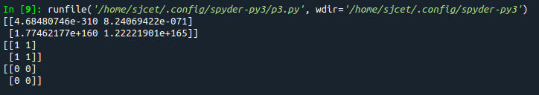
- Create an one dimensional array using arange function containing 10 elements.
Display
- First 4 elements
- Last 6 elements
- Elements from index 2 to 7

CODE:
import numpy as np
a = np.arange(1, 11, 1)
print(a)
first_element = a[:4]
print(first_element)
first_element1 = a[5:]
print(first_element1)
first_element2 = a[1:7]
print(first_element2)
OUTPUT:
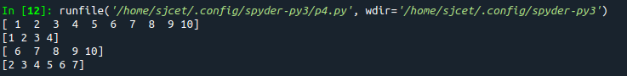
- Create an 1D array with arange containing first 15 even numbers as elements
- Elements from index 2 to 8 with step 2(also demonstrate the same using slice function)
- Last 3 elements of the array using negative index
- Alternate elements of the array
- Display the last 3 alternate elements
CODE:
import numpy as np

array_1d=np.arange(0,30,2)
print("array is:",array_1d)
print("Elements from index 2 to 8 with step 2",array_1d[2:8:2])
s=slice(2, 8, 2)
print("Elements from index 2 to 8 with step 2 using slice",array_1d[s])
print("Last 3 elements of the array using negative index",array_1d[-3:-1])
print("Alternate elements of the array",array_1d[::2])
print("Display the last 3 alternate elements",array_1d[-3:-1:2])
print("Display the elements from indices 4 to 10 in descending order(use-values)")
print(array_1d[10:4:-1])
OUTPUT:
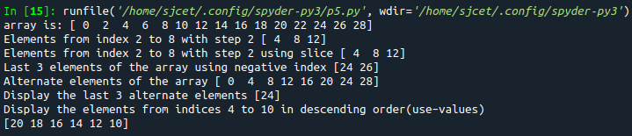
- Create a 2 Dimensional array with 4 rows and 4 columns.
- Display all elements excluding the first row
- Display all elements excluding the last column
- Display the elements of 1st and 2nd column in 2nd and 3rd row
- Display the elements of 2nd and 3rd column
- Display 2nd and 3rd element of 1st row
- Display the elements from indices 4 to 10 in descending order(use –values)
CODE:
import numpy as np

array_2d=np.array([[1,2,3,4],[5,6,7,8],[9,10,11,12],[13,14,15,16]])
print(array_2d)

print("Display all elements excluding the first row")
print(array_2d[1:4,:])
print("Display all elements excluding the last column")
print(array_2d[:,0:3])
print("Display the elements of 1 st and 2 nd column in 2 nd and 3 rd row")
print(array_2d[1:3,0:2])
print("Display the elements of 2 nd and 3 rd column")
print(array_2d[:,1:3])
print("Display 2 nd and 3 rd element of 1 st row")
print(array_2d[0,1:3])
OUTPUT:
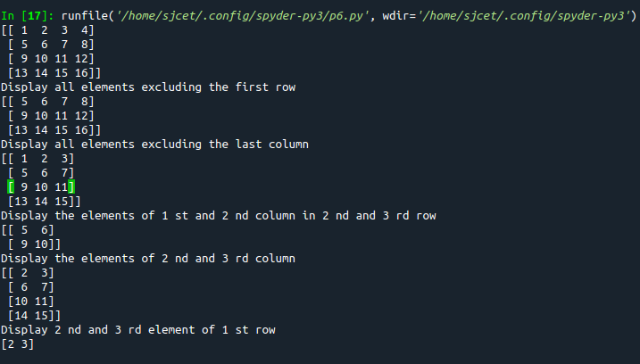
- Create two 2D arrays using array object and
- Add the 2 matrices and print it
- Subtract 2 matrices
- Multiply the individual elements of matrix
- Divide the elements of the matrices
- Perform matrix multiplication
- Display transpose of the matrix
- Sum of diagonal elements of a matrix

CODE:
import numpy as np

M1 = np.array([[3, 6], [14, 21]])
M2 = np.array([[9, 27], [11, 22]])

M3 = M1 + M2
print("Matrix addition")
print(M3)

M3 = M1 - M2
print("Matrix Substract")
print(M3)

M4 = np.array([[3, 6], [5, -10]])
M5 = np.array([[9, -18], [11, 22]])
M3 = M4 * M5
print("Multiply the individual elements of matrix")
print(M3)

M3 = M1 / M2
print("Divide the elements of the matrices")
print(M3)

M3 = M4.dot(M5)
print("matrix multiplication")
print(M3)

M6 = np.array([[3, 6, 9], [5, -10, 15], [4,8,12]])
M7 = M6.transpose()
print("Transpose of the matrix")
print(M2)

print("Sum of diagonal elements of a matrix")
print(np.trace(M6))
OUTPUT:
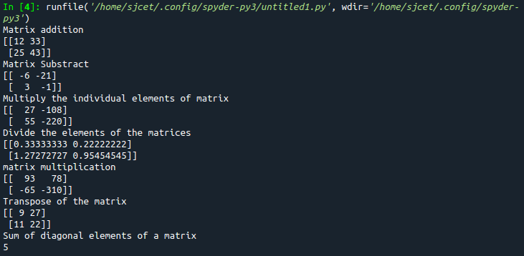
- Demonstrate the use of insert() function in 1D and 2D array

CODE:
import numpy as np

arr = np.arange(5)
print("1D arr : \n", arr)

a = np.insert(arr, 1, 9)
print("Array after inserting '9' : \n", a)

arr = np.arange(12).reshape(3, 4)
print("2D arr : \n", arr)

a = np.insert(arr, 1, 9, axis = 1)
print("Array after inserting '9' : \n", a)
OUTPUT:
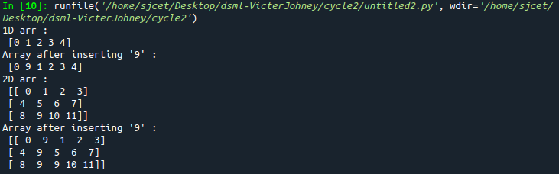
- Demonstrate the use of diag() function in 1D and 2D array.

CODE:
import numpy as np

arr = np.arange(1,6).reshape(1,5)
print("1D arr : \n", arr)

a = np.diag(arr)
print("1D Array Diagonal values : \n", a)

arr = np.arange(12).reshape(4, 3)
print("2D arr : \n", arr)

a = np.diag(arr)
print("2D Array diagonal values : \n", a)
OUTPUT:
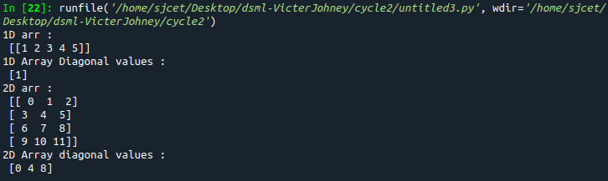
- Demonstarte the use of append() function in 1D and 2D array
CODE:
import numpy as np

arr = np.array([1, 2, 3, 4, 5, 6, 7])

a = np.append(arr, 88)
print("1D Array Diagonal values : \n", a)

arr = np.array( [ [1, 2, 3],[ 4, 5, 6] ])
print("2D arr : \n", arr)

a = np.append(arr, [22, 23, 24])
print("2D Array diagonal values : \n", a)
OUTPUT:
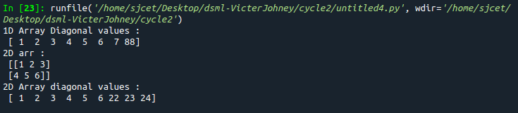
- Demonstarte the use of sum() function in 1D and 2D array.
CODE:
import numpy as np

arr = np.array([1, 2, 3, 4, 5, 6, 7])
print("1D arr : \n", arr)

a = np.sum(arr)
print("1D Array Sum : \n", a)

arr = np.array( [ [1, 2, 3],[ 4, 5, 6],[7, 8, 9] ])
print("2D arr : \n", arr)

a = np.sum(arr)
print("2D Array Sum : \n", a)
OUTPUT:
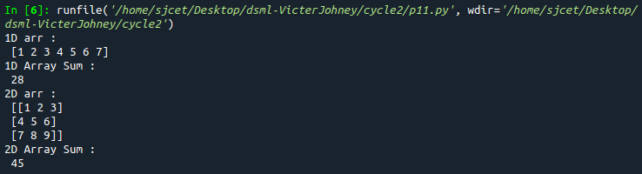

12. Create a square matrix with random integer values(use randint()) and use
appropriate functions to find:
i) inverse
ii) rank of matrix
iii) Determinant
iv) transform matrix into 1D array
v) eigen values and vectors
CODE:
import numpy as np
from numpy import random as r

x = r.randint(100, size=(3, 3))
print ("Square matrix with random numbers: \n",x)

print("Inverse: \n", np.linalg.inv(x))

print("Matrix Rank: \n", np.linalg.matrix_rank(x))

print("Determinant: \n", np.linalg.det(x))

print("Transform matrix into 1D: \n", np.ravel(x))

print("Eigen Value: \n", np.linalg.eig(x))
OUTPUT:
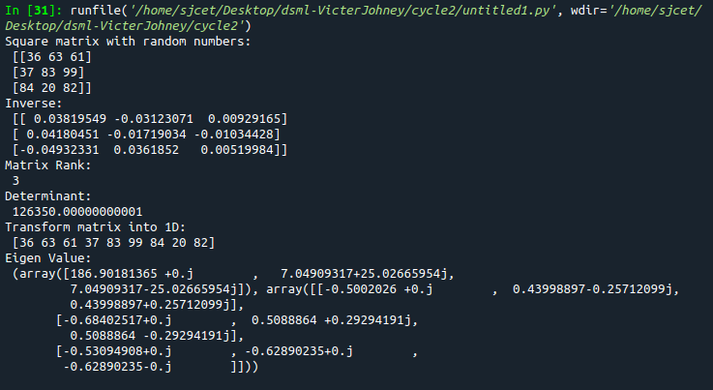
13. Create a matrix X with suitable rows and columns
i) Display the cube of each element of the matrix using different methods
(use multiply(), *, power(),**)
ii) Display identity matrix of the given square matrix.
iii) Display each element of the matrix to different powers.
iv) Create a matrix Y with same dimension as X and perform the operation X^2 +2Y
CODE:
import numpy as np

x = np.arange(1,10).reshape(3,3)
print(x)

print("Matrix cube using multiply(): \n",np.multiply(x,(x*x)))

print("Matrix cube using pow()): \n",np.power(x,3))

print("Matrix cube using *: \n",x*x*x)

print("Matrix cube using **: \n",x**3)

print("Identity Matrix of 3x3: \n",np.identity(3,dtype=int))

print("each element of the matrix to different powers: \n",np.power(x,x))

y = np.arange(11,20).reshape(3,3)
#print("x : \n ",x)
#print("y : \n ",y)
#print("x^2 : \n ",np.power(x,2))
#print("2y : \n ",np.multiply(y,2))
print("perform the operation X^2 +2Y: \n",np.add((np.power(x,2)),(np.multiply(y,2))))
OUTPUT:
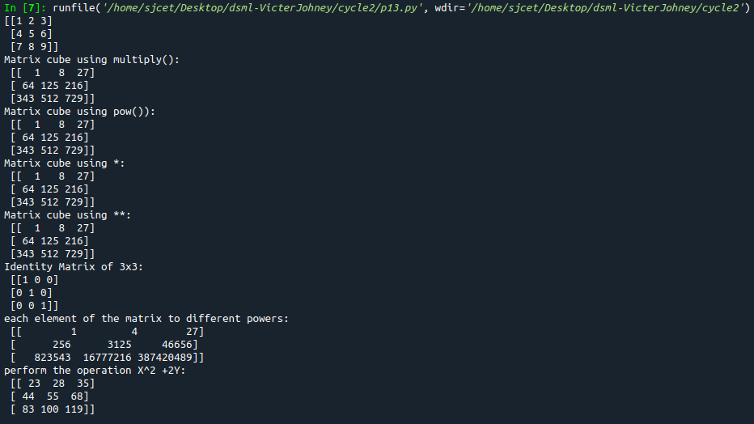
14. Multiply a matrix with a submatrix of another matrix and replace the same in larger
matrix.
CODE:
import numpy as np;

x = np.arange(1,31).reshape(5,6)
print("x-> big matrix :\n",x)
#x[column,row]
y=x[1:4,2:5]

#print("y-> sub matrix of x : \n",y)

z = np.arange(2,11).reshape(3,3)
#print("matrix z :\n",z)

y = np.multiply(y,z)

#print("multiplied matrix : \n",y)

x[1:4,2:5] = y

print("final replaced matrix:\n ",x)
OUTPUT:
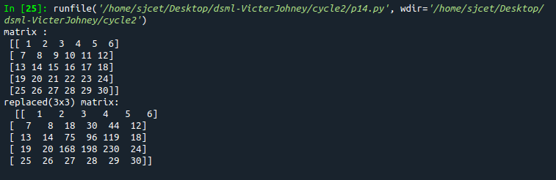
15. Given 3 Matrices A, B and C. Write a program to perform matrix multiplication of
the 3 matrices.
CODE:
import numpy as np

A =np.array( [[12, 7, 3],[4, 5, 6],[7, 8, 9]])
print("Matrix A:\n ",A)
B = np.array([[5, 8, 1, 2],[6, 7, 3, 0],[4, 5, 9, 1]])
print("Matrix B:\n ",B)
C = np.array([[1, 7, 3],[3, 5, 6],[6, 8, 9],[2, 9, 1]])
print("Matrix C:\n ",C)
result=np.dot(A,B)
#print(result)
new=np.dot(result,C)
print("Products of 3 mtrices is: \n", new)
#print(np.dot(np.dot(A,B),C))
OUTPUT:
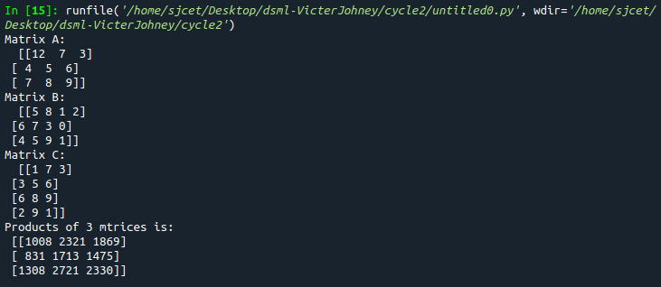
16. Write a program to check whether given matrix is symmetric or Skew Symmetric.
CODE:
import numpy as np;

x = np.arange(1,10).reshape(3,3)
print("Matrix x: \n", x)
# Transposing the Matrix M
y=x.transpose();
print("Transpose of x :\n ",y)
# -1(Transpose)
skew=np.multiply(y,-1);
print("negative of transpose :\n ",skew)
if x.all() == y.all():
print("Matrix is symmetric")
else:
print("Matrix is not symmetric")
if x.all() == ~y.all():
print("Matrix is skew symmetric")
else:
print("Matrix is not skew matrix")
OUTPUT:
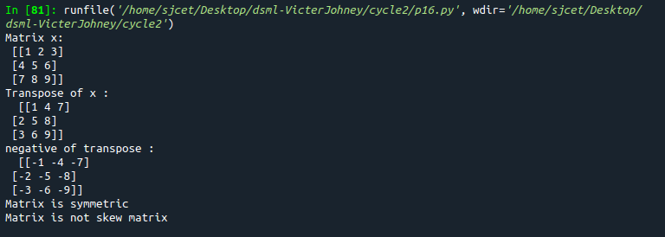
17. Write a program to find out the value of X using solve(), given A and b as above
CODE:
import numpy as np;

A=np.array([[2,1,-2],[3,0,1],[1,1,-1]])
b=np.array([[-3],[5],[2]])

print("A:\n",A)
print("b:\n",b)

X=np.multiply((np.linalg.inv(A)),b)
print("X is : \n",X)
OUTPUT:
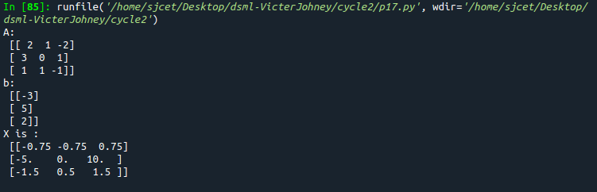
18. Write a program to perform the SVD of a given matrix. Also reconstruct the given matrix from the 3 matrices obtained after performing SVD.
CODE:
import numpy as np;

A = np.array([[1, 2], [3, 4], [5, 6]])
print("Matrix:\n",A)
# SVD
U, s, VT = np.linalg.svd(A)
print("U:\n", U)
print("Sigma:\n",s)
print("V^T:\n",VT)
OUTPUT:
